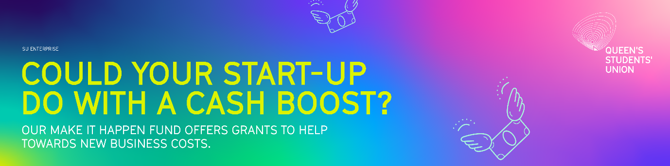
The ‘Make it Happen Fund’ is open to all current undergraduate and postgraduate students at Queen’s University Belfast
MAKE IT HAPPEN FUND APPLICATION FORM 2025-2026
Name

Business Name (if applicable)

Student Number

Email Address
Course
Year of graduation
Are you currently on a student VISA? If yes, please provide details
Business Stage | Pre-Start (No income generated): ☐  Early Trading (Less than £1,000 of income): ☐

Tell us about your business idea
What is it? How does it work?

Who will buy your product or service?
Who are your potential customers? (Business or consumer, demographics etc.)

U.S.P
What is unique about your product or service? (What makes you better than your competitors?)

The Research
Who have you spoken to? What research have you carried out to establish whether this idea is viable? What were your findings from this research?

Support so far
Can you tell us what support you have received so far? (E.g. meetings with SU Enterprise, other programmes or funding received).

The Money
Send us a breakdown of what you will need the ‘Make It Happen Fund’ for? (Try and make this as accurate and detailed as possible)

Please send your completed application form to su.enterprise@qub.ac.uk by Monday 20th October 2025 at midday
Please note that it is not permitted to be registered as self-employed or trade as a business on a Tier 4/Student visa. If you have any questions about the Terms and Conditions of your Tier 4/Student visa, please visit the Home Office website https://www.gov.uk/student-visa or contact International Student Support at immigration@qub.ac.uk.

